Insole Full System Version 1

This version relies on a square base made of hard plastic, two tubes made of soft plastic, and a top made of soft plastic. The piezo buzzer is held in place by the groves in the hard plastic base and the center is forced upwards by two off center tubes. Then the top holds the components together. The hole thing ends up being 6mm tall.

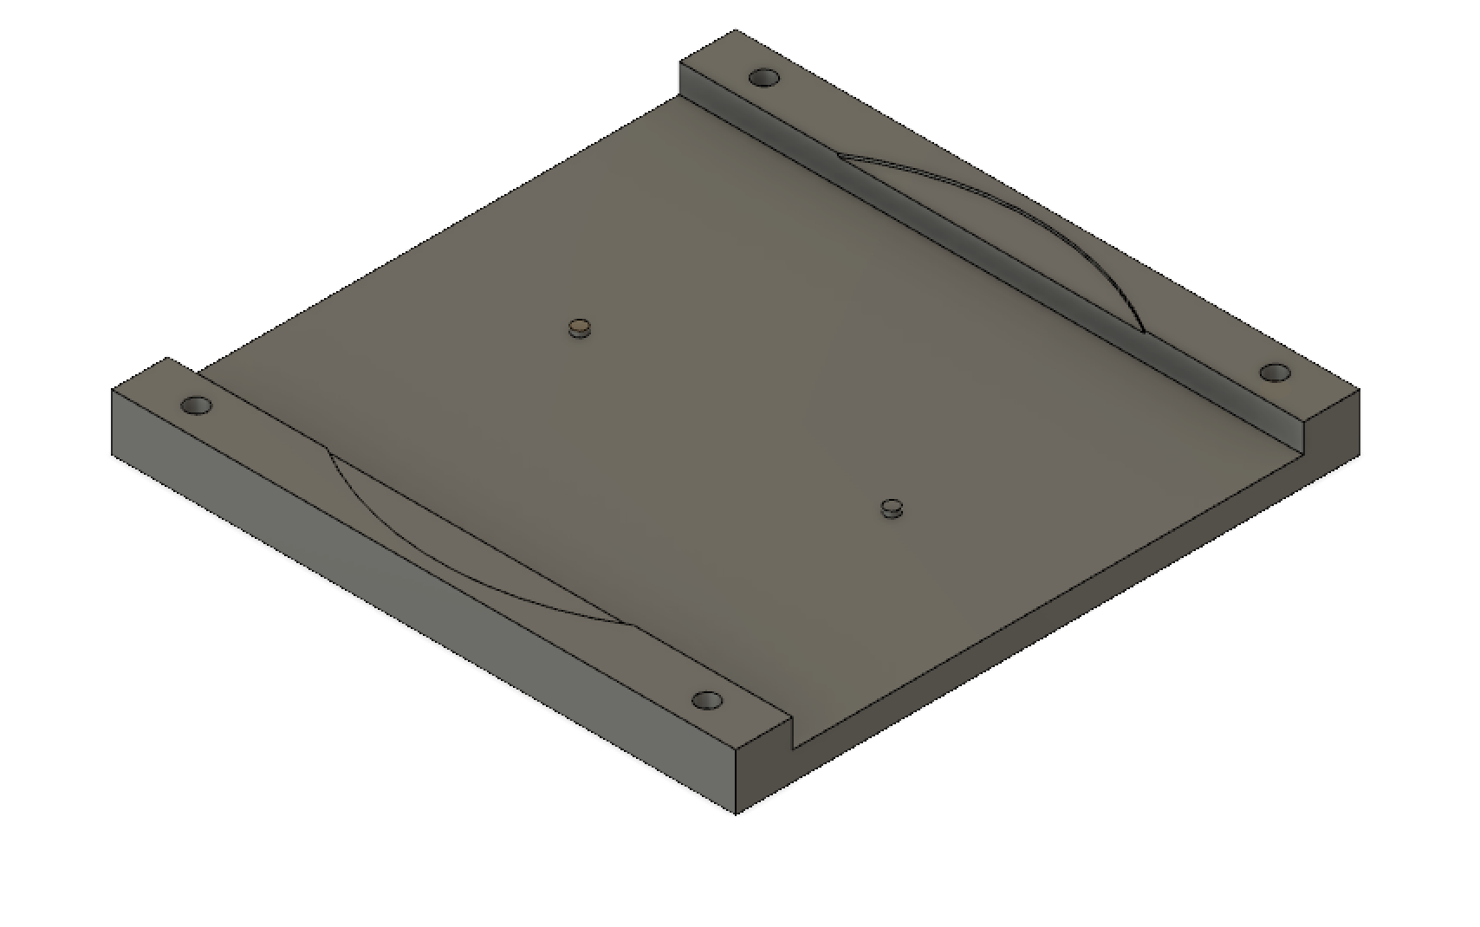

Hard plastic base.

44mm x 44mm x 4mm

The bottom is 2mm of solid plastic allowing for 2mm of bending room for the buzzer.

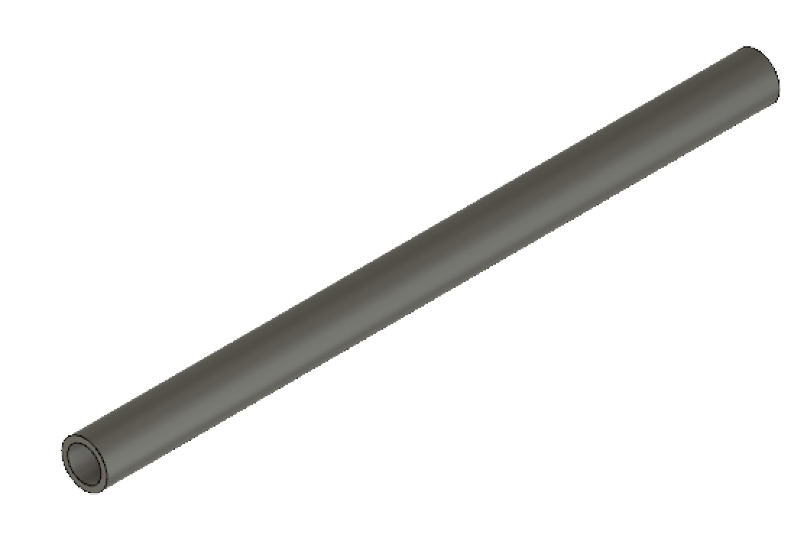

Soft plastic tubes.

Outer radius = 1.5mm

Inner radius = 1.1 mm

Length = 44mm

The tubes are glued to the base slightly off center.

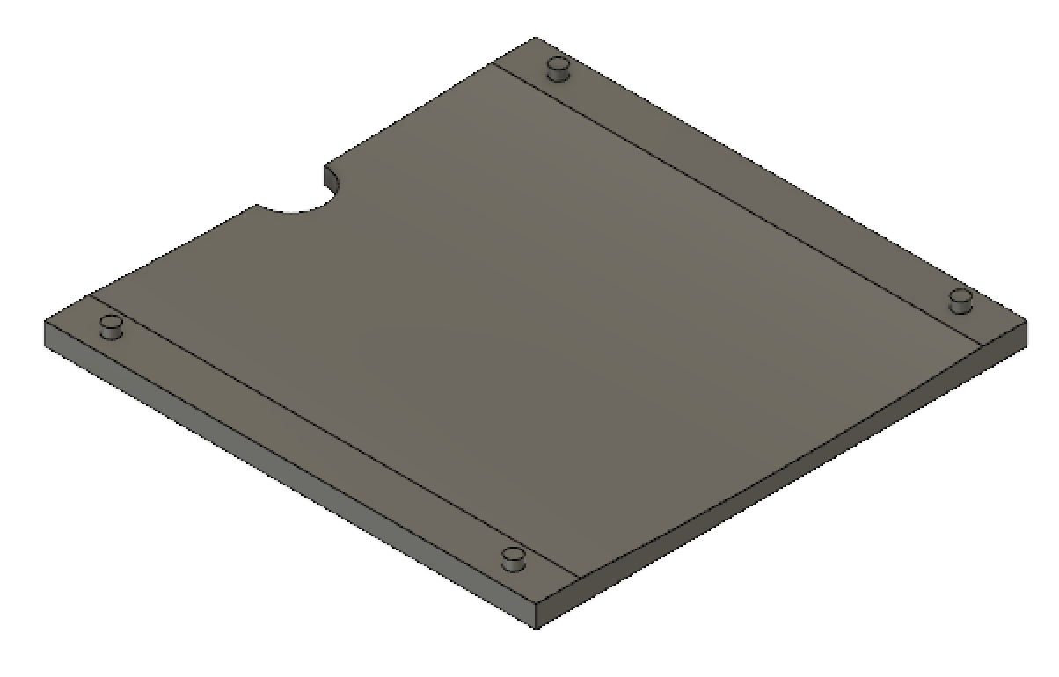

Top of the buzzer holder. Soft plastic.

44mm x 44mm x 2mm

The top is glues onto to base to hold the buzzer down.

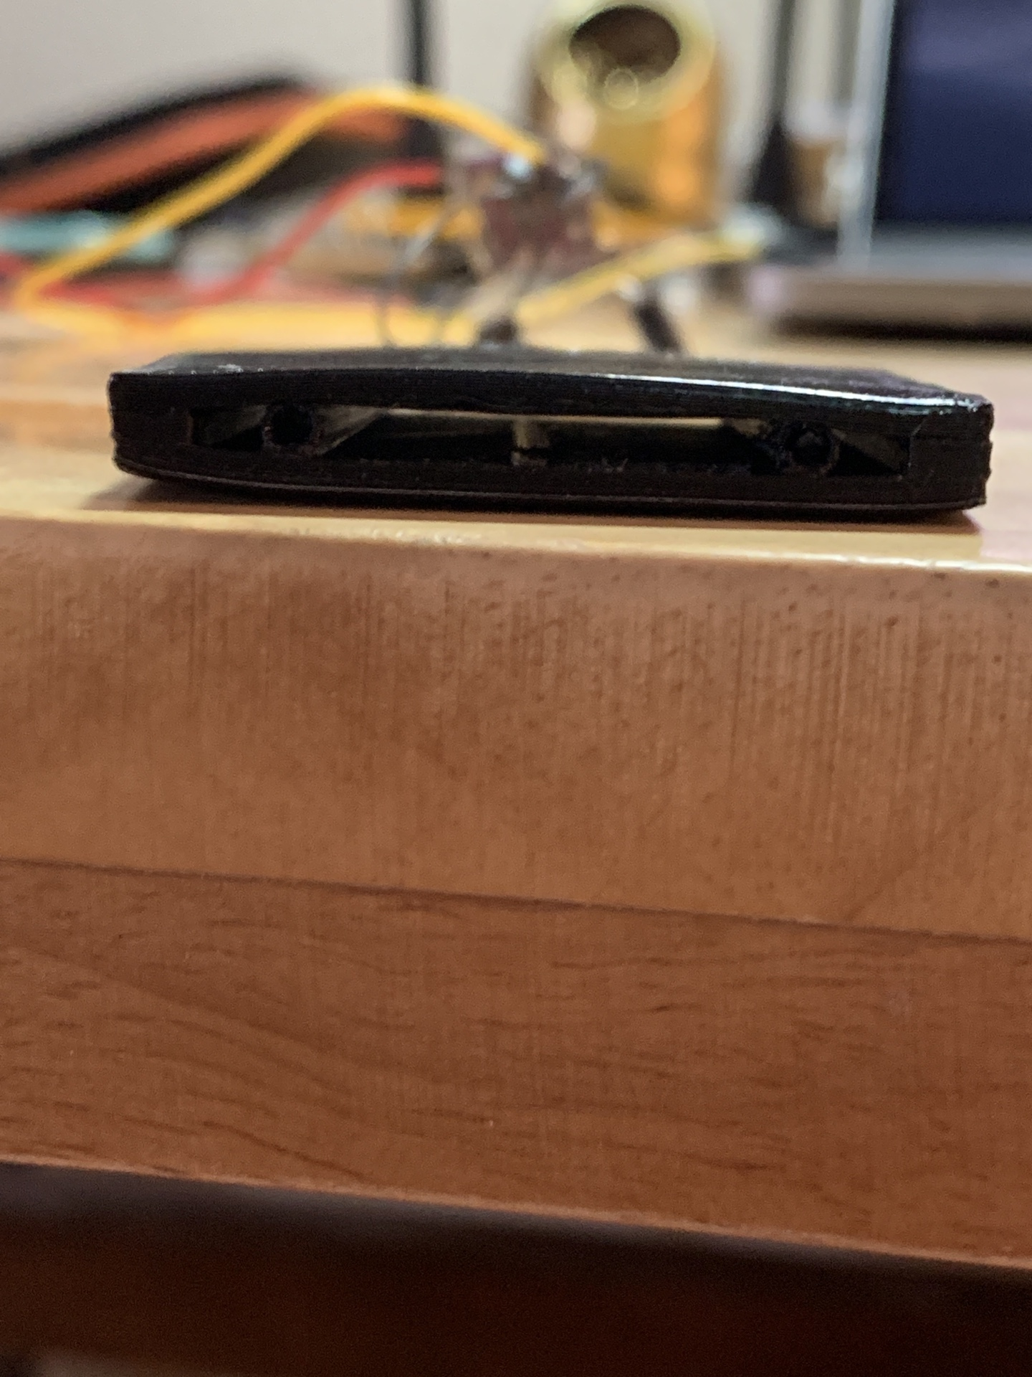

Assembled system.

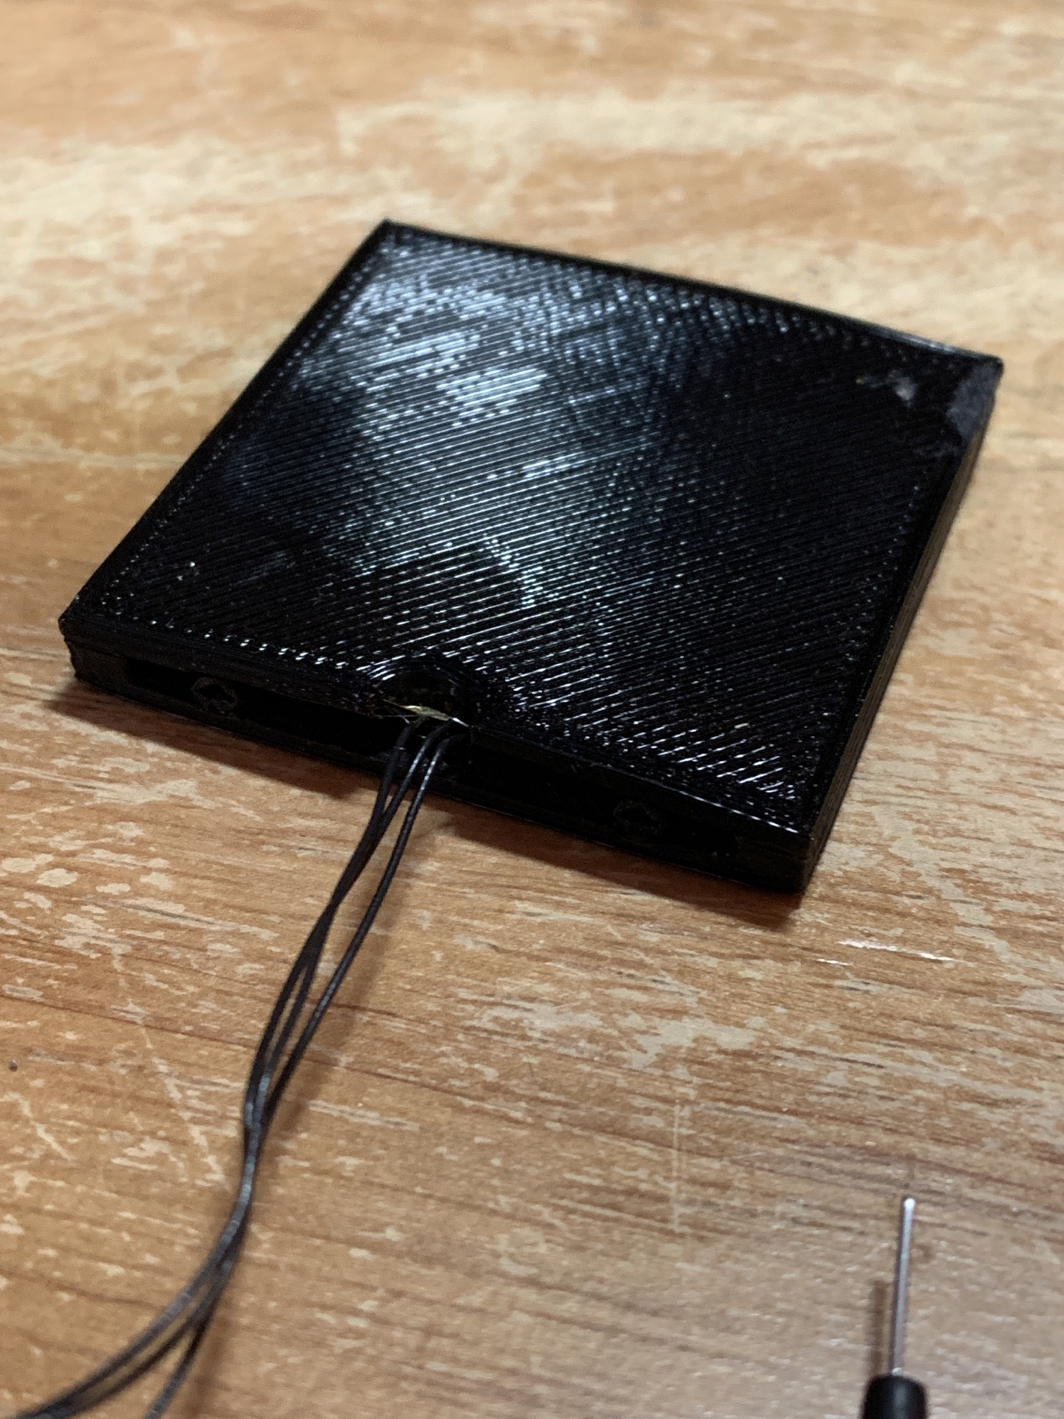

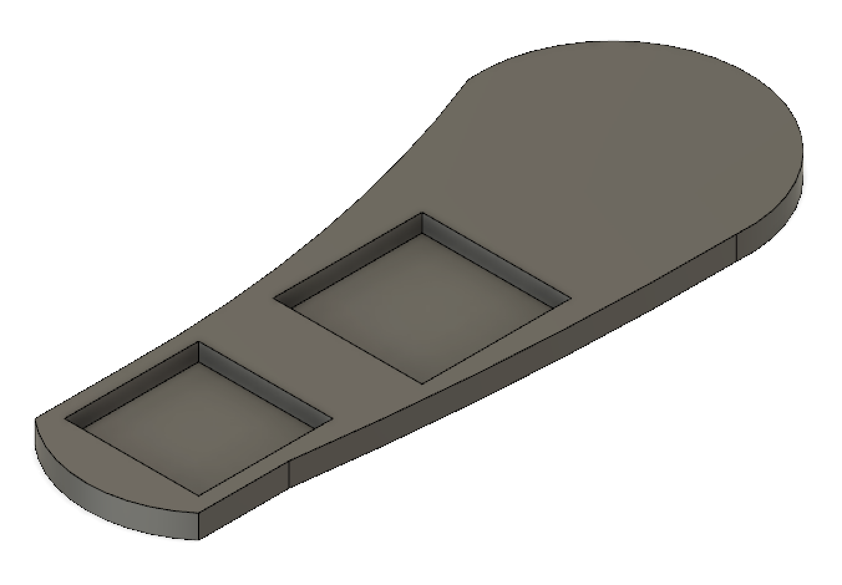

Insole to contain the buzzer holder and go inside the shoe. Made of soft plastic. The heel is where the buzzer holder goes and the center is for the energy harvester, capacitors, and micro controller.

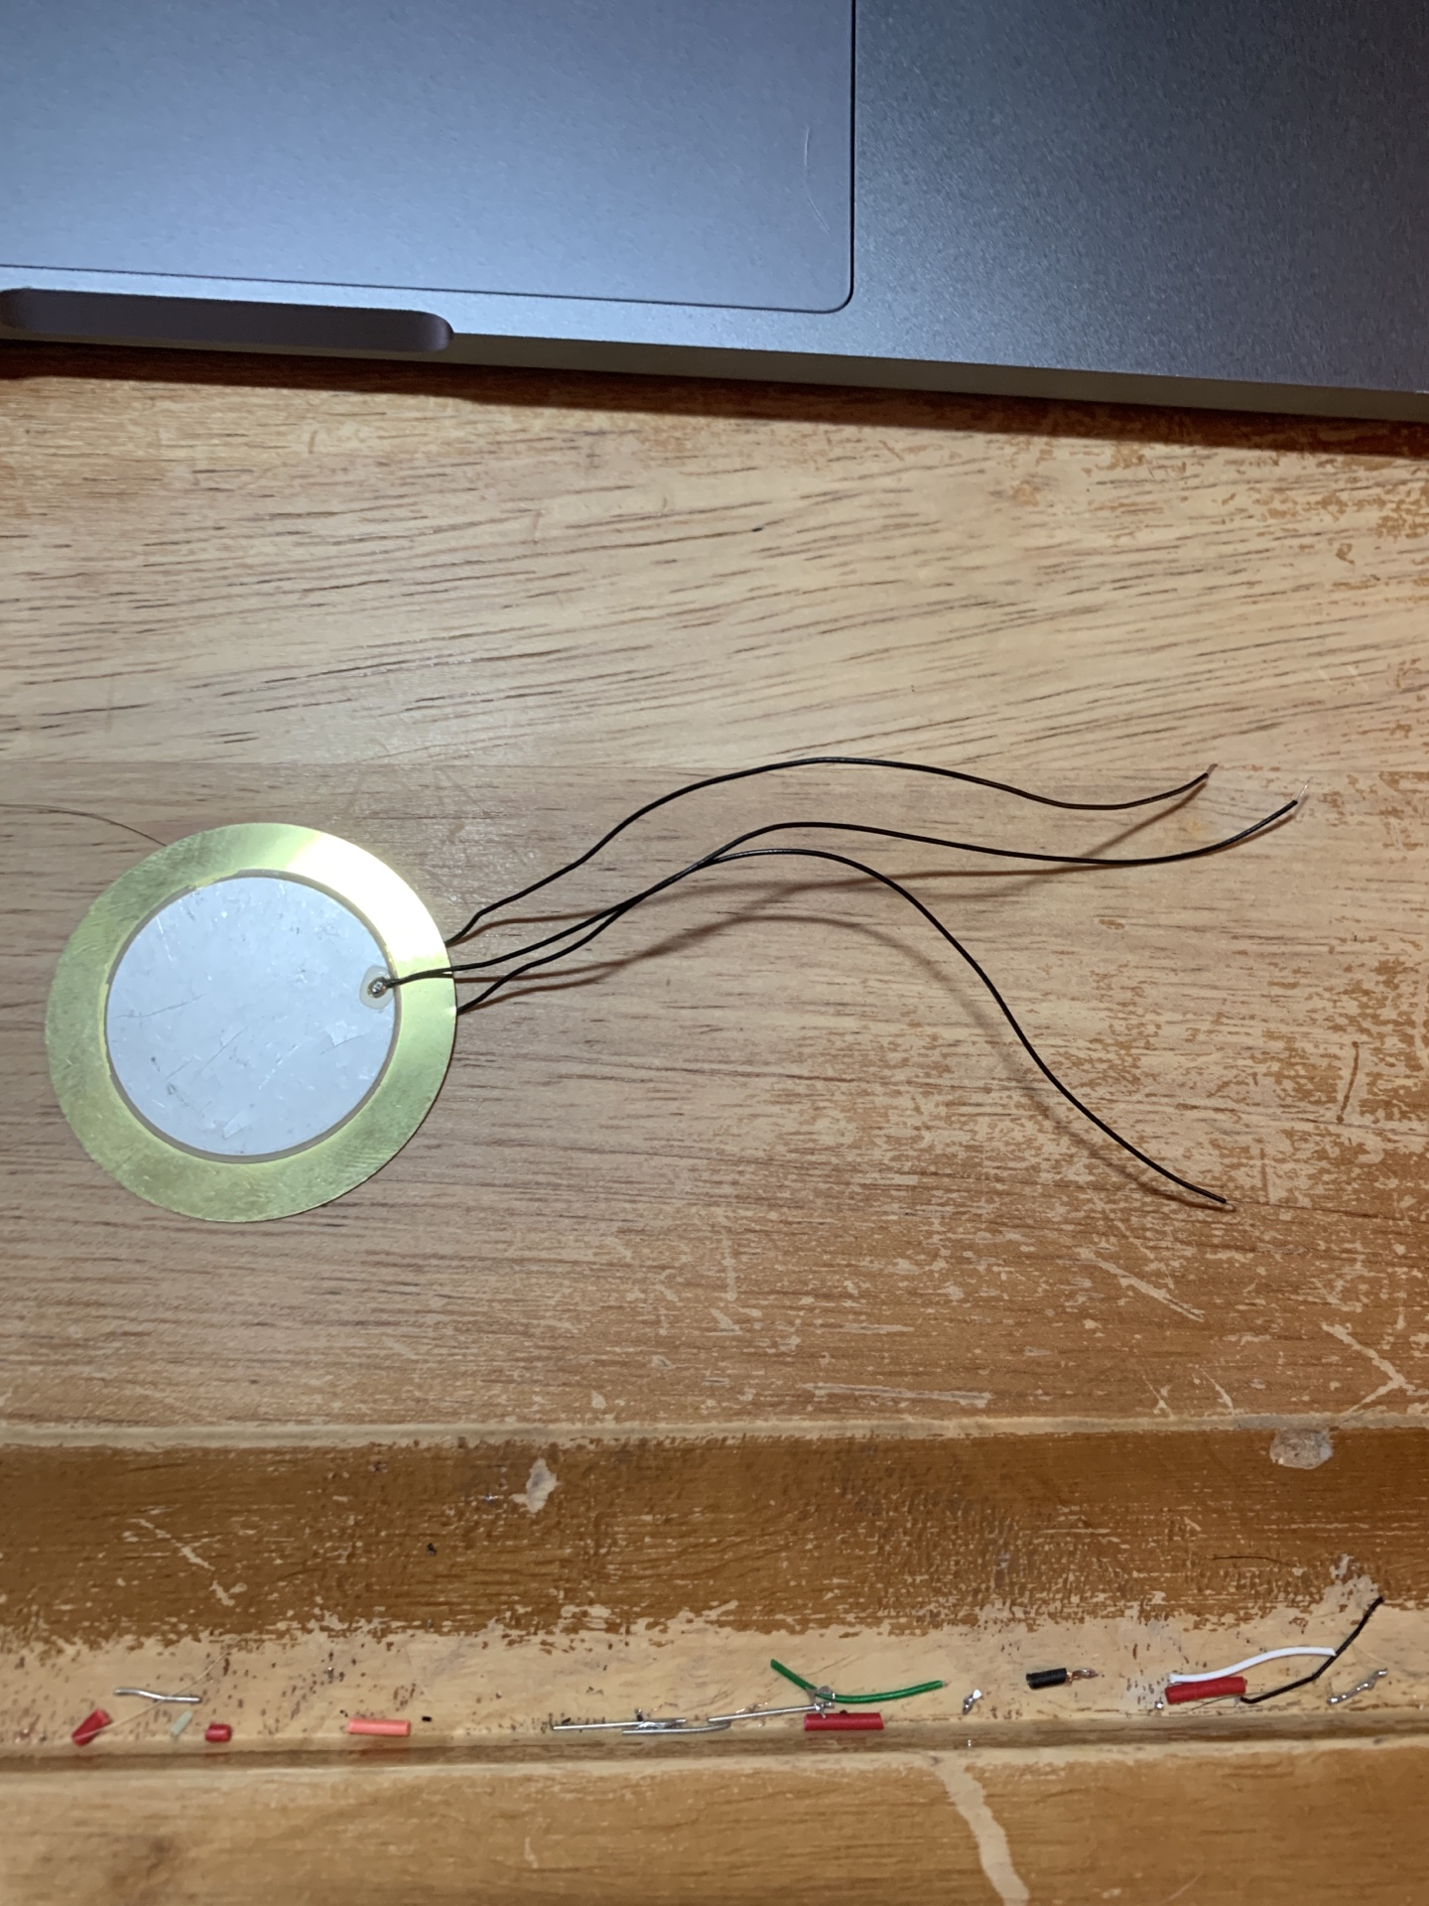

Buzzer used.

**Background:**

The micro controller transmitting a packet every 1 second consumes about 16uJ. Tests assume a 1Hz walk, thus the absolute minimum for energy per step is 16uJ. A safe amount of energy per step assuming all the micro controller will be doing is transmitting once per second will be considered to be 40uJ, more than twice the minimum requirement.

The buzzer has piezoceramic on both sides. The ceramic connected wires can be soldered together and the brass connected wire and the soldered together ceramic connected wires are to be the two inputs into a full bridge rectifier.

**Performance:**

The performance was measured by connecting the buzzer system to the energy harvester and counting the number of full presses it takes to charge the capacitors to a certain voltage.

Voltage target for 22uF input capacitor: **10V**

Voltage target for 47uF output capacitor: **3.6V**

Energy stored at voltage targets:

(.5 * 22e-6 * 10^2 + .5 * 47e-6 * 3.6^2) = **1400uJ**

**Test ran by pressing system with finger.**

Presses required after multiple tests of varying speed: **26 presses**

Result: **54uJ per press**

**Test ran by stepping on system in the insole component.**

Steps required after multiple tests of varying speed: **60 steps**

Result: **23uJ per step**

In either case the buzzer should theoretically have enough energy to supply the micro controller transmitting a packet once per second at 3.6 volts.

**Strength Analysis:**

System is capable of withstanding a sustained full force step and jumps without any visible damage to any part.

After multiple tests and uses there seems to be slight damage to glue bonds.

The flexible tubes degrade in shape, reducing performance.

**Insole flexibility:**

The insole is comfortable to stand on and not very intrusive in a shoe.

It is capable of conforming to any bend I was able to apply to it while in the shoe.

**Problems and areas of improvement**:

The insole does not properly fill a shoe or conform to the shape very well.

Only one slot for buzzer components. Another could potentially exist around the toe area.

The insole has no space for wires to go from buzzer area to component area.

Edges of the buzzer component seem to impair a heel from being able to fully depress the center of the buzzer, resulting in less bend and less power output.

The buzzer component is held together with glue which seems to degrade over time.

The tubes themselves put constant pressure on the top to base glue bond. Since the top is the part holding the buzzer in a glue failure in this area results in total failure.

The size of the tubes appears to be too small to properly print. The come out slightly stringy and are not very resistance to pressure from the start. Printing them upright may help but it it probably ideal to make the difference between the inner and outer radius greater.

The area for bending of the buzzer is a total of 2mm. When in the shoe or under constant pressure this space becomes constantly compressed. This results in even less bending area and thus less power output. The buzzer seems to be completely capable of handling the full amount of bend possible from this design so in future ones a greater bending area should be implemented.

The power output when stepped on is in theory enough to power the microcontroller, but there is not a safe margin of extra power.